Primary Document Analysis

Alexa Brickenden
History 3510
Tracy Penny Light
November 7, 2017

The primary source that will be analyzed is a Tashme Camp Supervisor Report from May 1945. This primary source was found on the Tashme Historical Project, 1942-1946 website. The thesis for this analysis is that the document helps readers in today’s society understand the attitudes of the Anglo-Saxon community in British Columbia towards Japanese people in this time period. The majority population of British Columbia during WWII saw the Japanese as enemy aliens due to the attack on Pearl Harbour. This caused the internment of the Japanese population in camps like Tashme. The Anglo-Saxon community held prejudiced, discriminatory, and racist attitudes towards the Japanese. This document also gives readers insight on the living conditions of a Japanese internment camp.
So, how does this document help to deliver understanding of attitudes towards the Japanese community in this time period? First to be discussed is how the author of this document influences this understanding. It is stated on the document that his name was Walter E. Hartley and that he was a supervisor at the Tashme camp. From his name, it can be assumed that he was a white male. Upon searching for a photo or further documentation of Walter E. Hartley nothing could be found. It must also be questioned that there is no signature on this document from Hartley, or anyone else. On the second page of the report, a faint signature is visible, but it cannot be determined who it belongs to. It also appears that there could be more to the document, potentially on the other side. However, it is unknown if that is more of the document or other unrelated papers.
This document is not written in a personal format, such as a journal, but rather it looks like a formal government report. Because of this, no personal bias or prejudices can be seen from Walter E. Hartley in this report. While this document is untouched by personal opinions or biases, it cannot be concluded that Hartley did not carry any prejudices of his own towards the Japanese people.
Second to be discussed is the content of the document and how it expresses attitudes of discrimination of the Anglo-Saxons in B.C towards the Japanese community. In the second category in the report, Hartley summarizes the conditions of the hospital facilities. It is stated that the hospital is run by a white doctor, but is “assisted by a fully qualified Japanese doctor”. This statement demonstrates the race inequality at play. Even though the Japanese people are already segregated into internment camps, the Caucasian community furthers their discrimination by giving the camp a white doctor. The same inequality is seen with the nurses. This section of the document also states that there were only fifty beds put into the hospital. The Tashme camp contained a total of 2,306 residents. It can be argued that the supply of beds is not sufficient for the size of the population and is an act of neglect on the part of the government.
Third, the living conditions of the Tashme camp show how Japanese people were viewed by the Anglo-Saxon community in British Columbia. The report states that the houses built in the internment camp accommodated eight people per house. One must question the size of those houses. In modern society, a house that accommodates eight people conjures an image of a large space. However, in the conditions of an internment camp this is probably not the case. The fact that the supervisor, Hartley, does not mention the living conditions of these houses is concerning and makes it seem as though the government is attempting to hide the living conditions it has created for the Japanese people. As the Japanese people were seen as enemy aliens due to the attack on Pearl Harbour, the government did not treat them as human beings.
The control of education and religion in the Tashme internment camp should also be examined. The document states that while the teachers in the camp were Japanese, they were under the supervision and control of the Commission. It is not stated in this document as to why this is. It can be argued that the Commission controls the education so that the students are learning material that will help them to assimilate to the Canadian culture. It is also not stated what language is being spoken around the camp and in the schools. Are the residents and the students allowed to speak Japanese? Or is it enforced by the government that they speak English?
The document also states that the religious denominations present in the Tashme camp are: The Church of England, the United Church, Catholic and Buddhist. It is critical to note that it is not stated what religion the population of the camp wishes to practice. The document only states what religious denominations are provided to the camp. This also supports the wishes of British Columbia to assimilate the Japanese.
In conclusion, this Supervisor Report provides evidence of the discriminatory attitudes towards the Japanese people in British Columbia during WWII. This document also helps readers in today’s society understand the living conditions of Japanese internment camps in BC. A critical question that is raised when reading this article is what the supervisor is leaving out of his report. Squalor living conditions, education and religion to promote assimilation, and race inequality are some examples. Furthermore, this document must be questioned because there is no supporting evidence that this report is delivering the full truth. There is the potential that it is a forged document, or that Walter E. Hartley was not truthful in his reporting. To expand on that, it is crucial to keep in mind that the report is written from the perspective of a supporter of the internment camp. At a time when the Japanese were seen as enemy aliens by the Anglo-Saxon majority in British Columbia, a report on the internment camp conditions, written by a white male, must be read with a critical and apprehensive perspective.

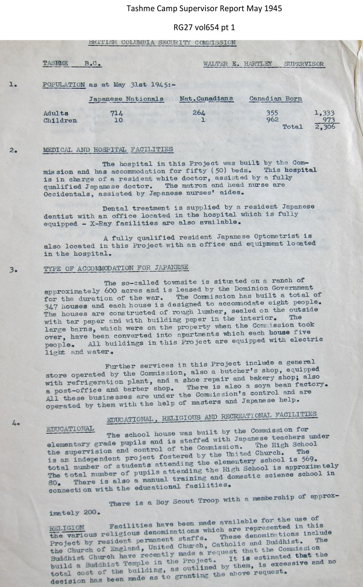

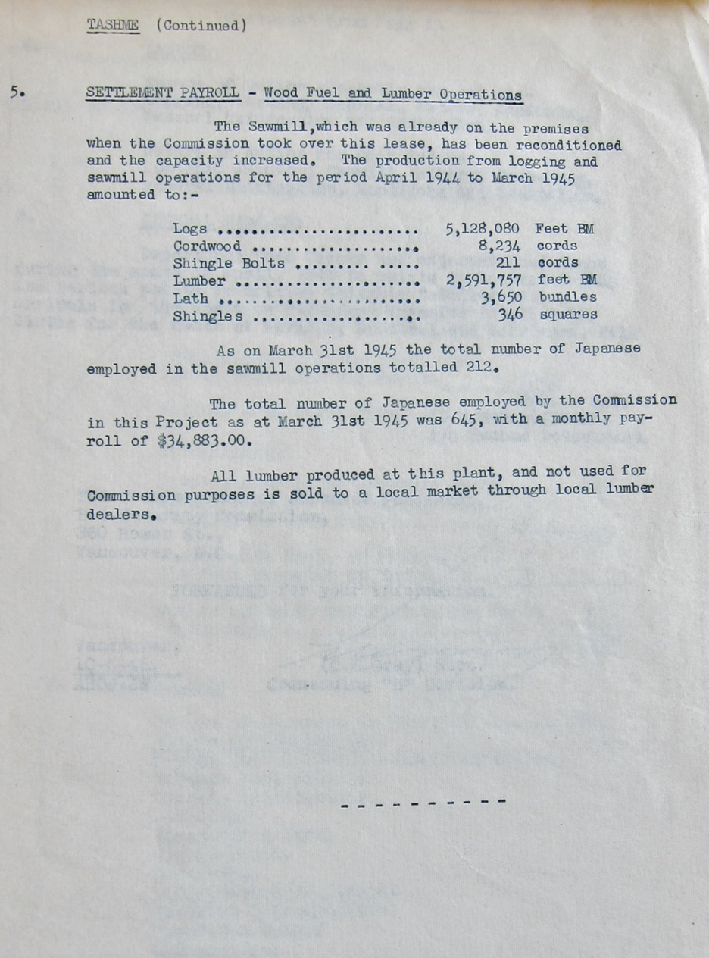
http://tashme.ca/camp-organization/tashme-governance/tashme-camp-supervisor-repo

